To run document registry: (Use hotspot if NPWirelessx does not work)

Launch ipfs daemon

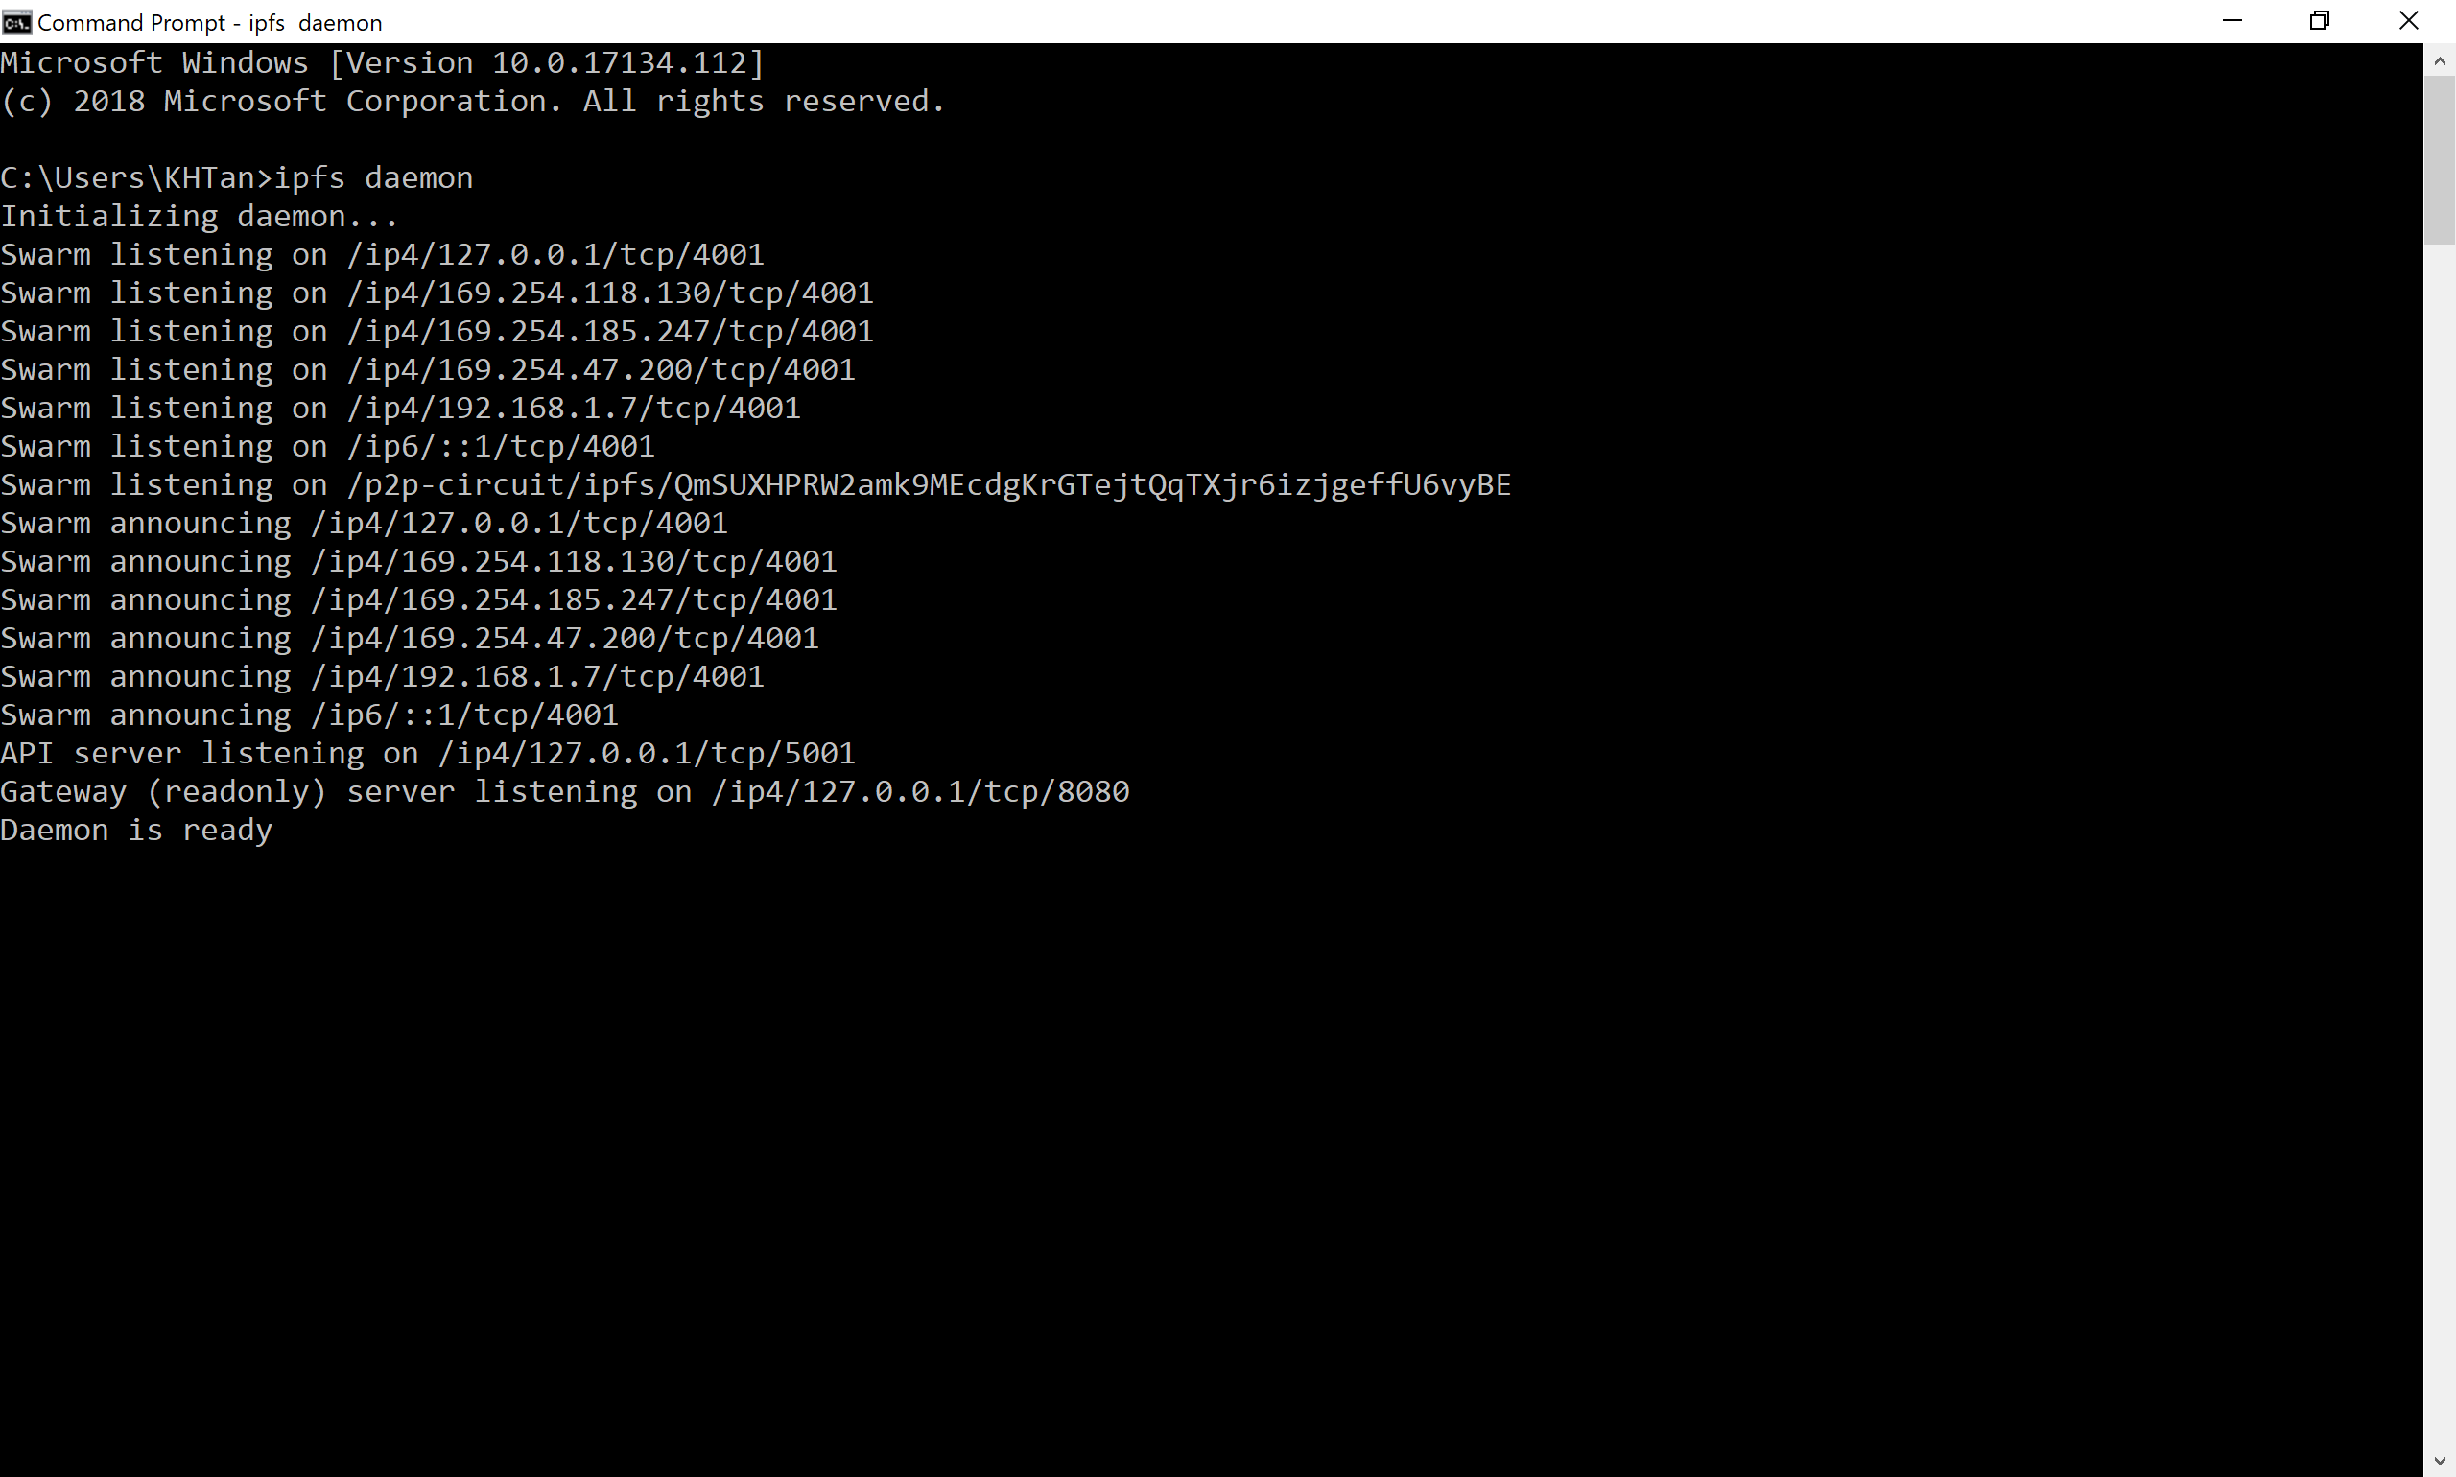

Launch Visual Studio. Run

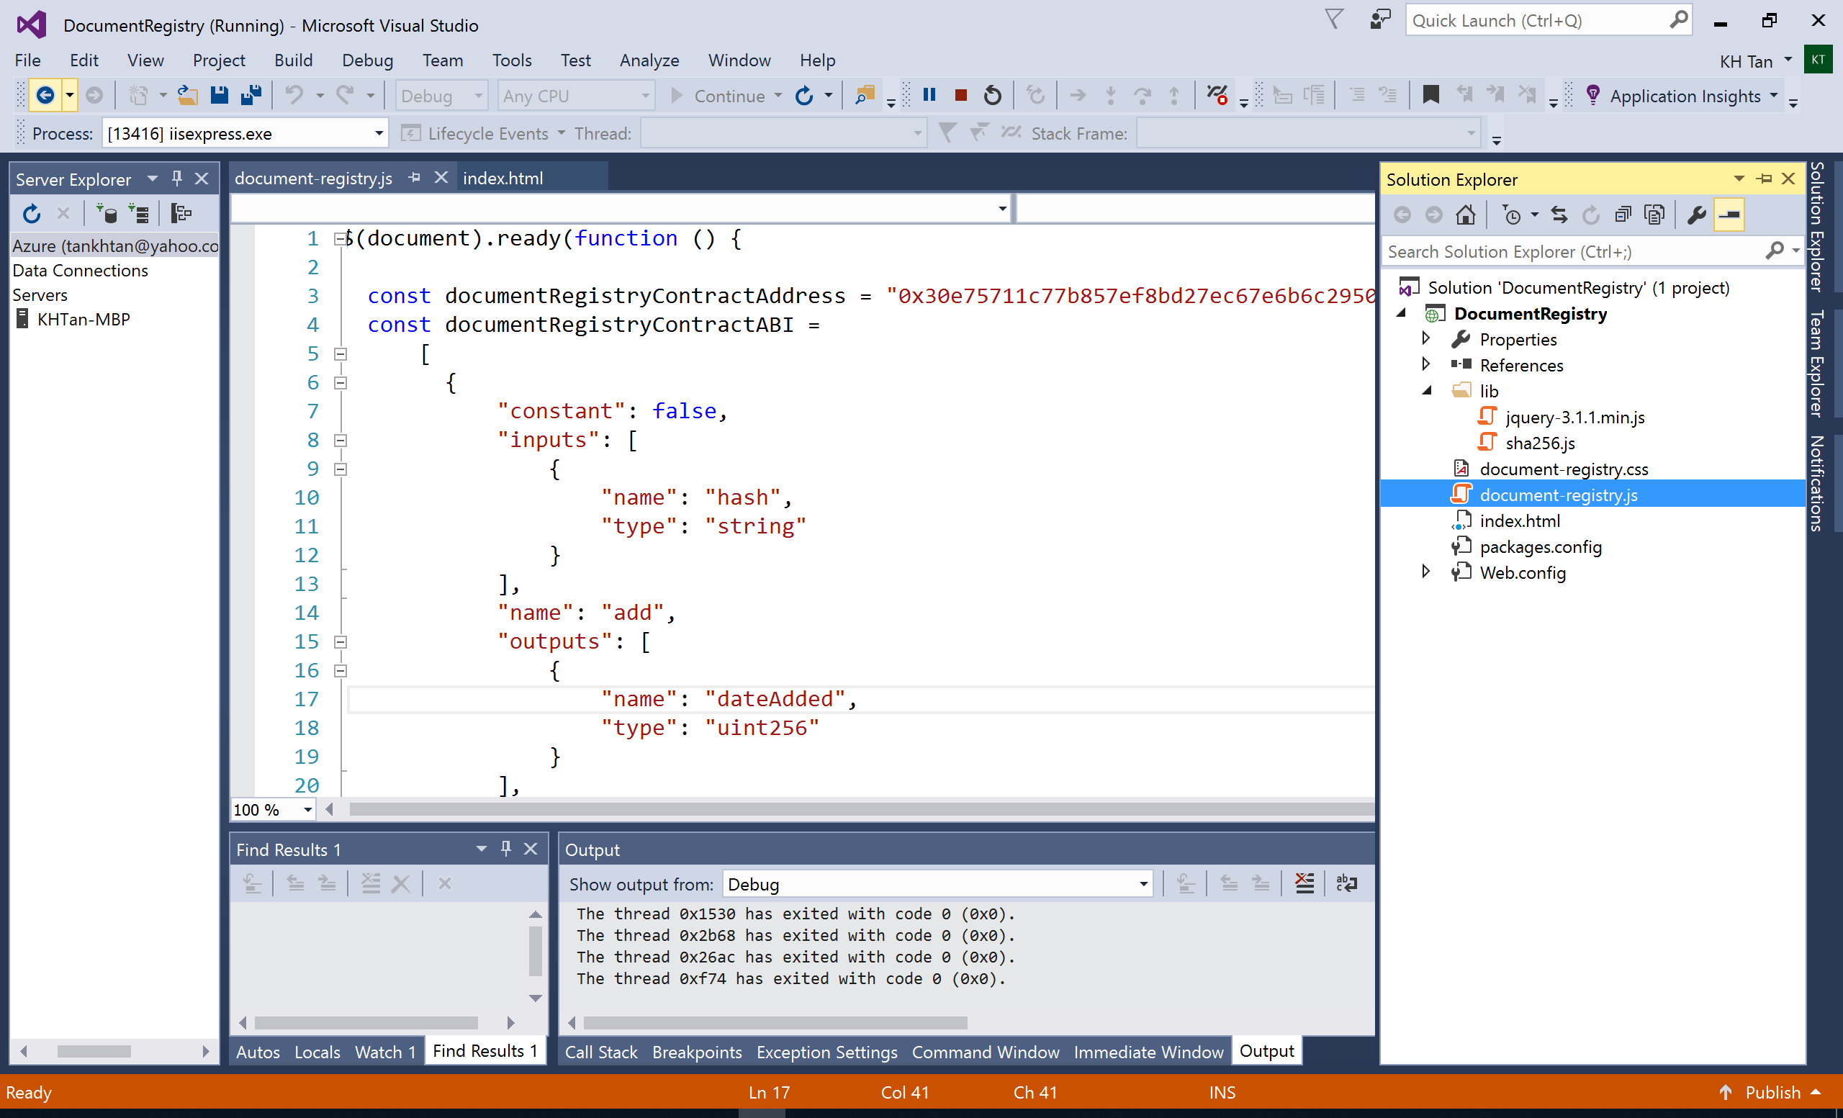

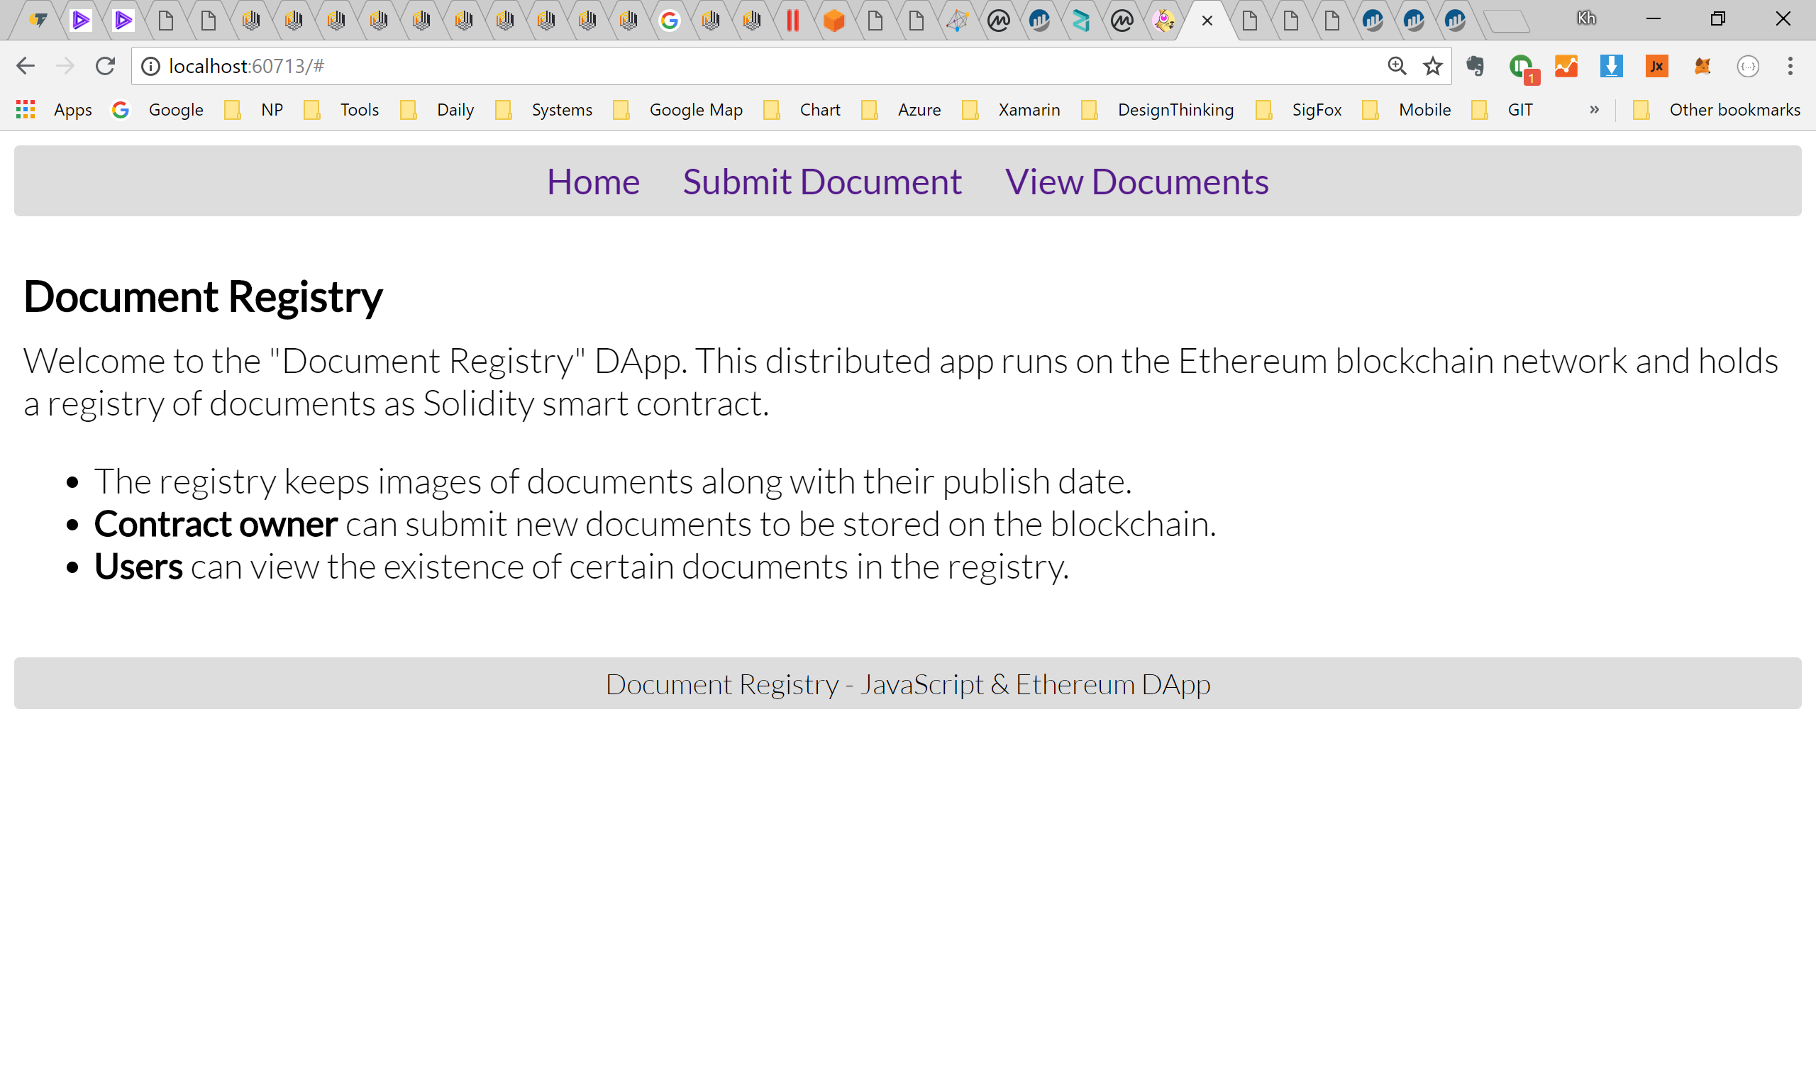

Launch MetaMask. Select Account 1 and Ropsten Test Net

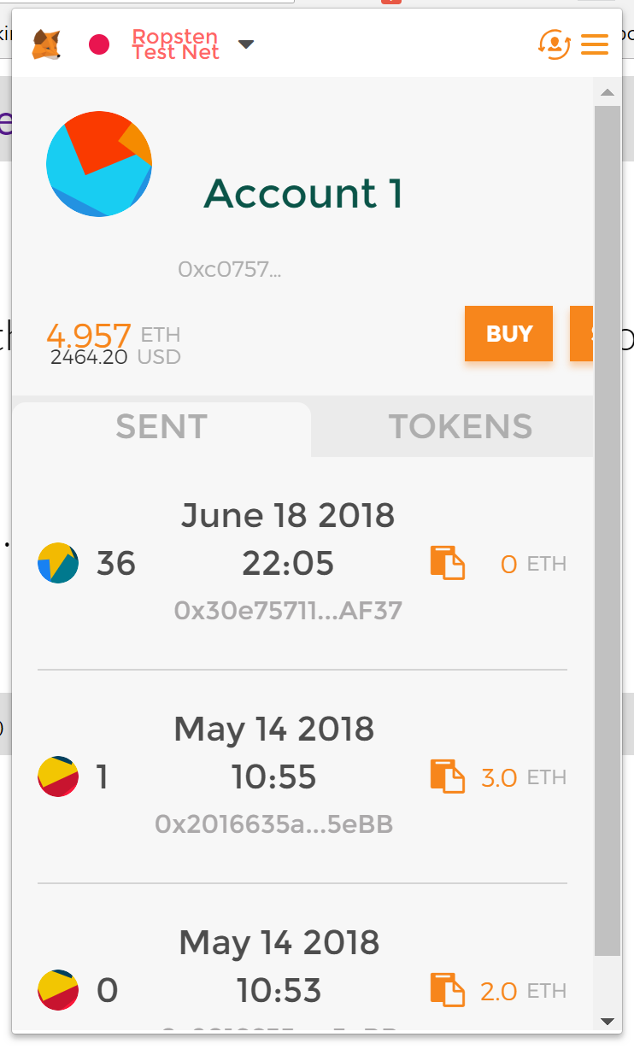

Click Submit Document

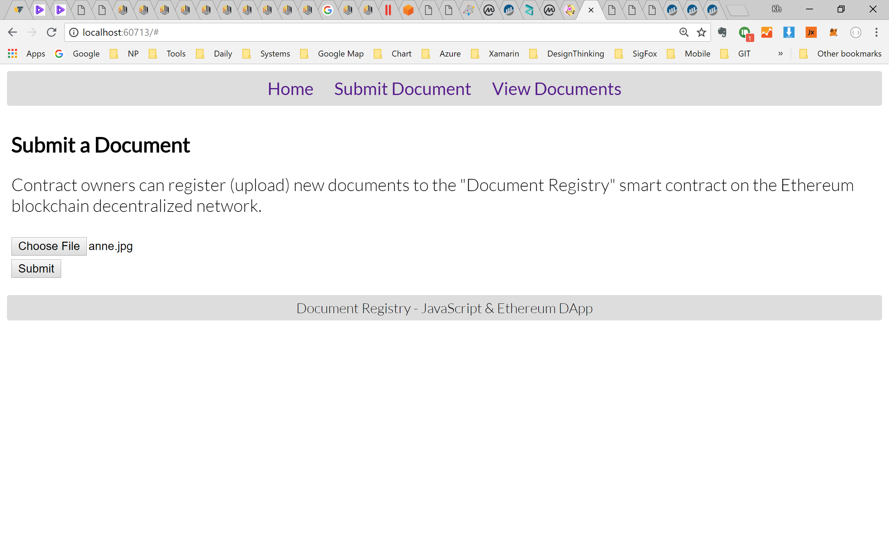

Select file to upload. Click Submit

View submitted file on ipfs. Qm… is the hash

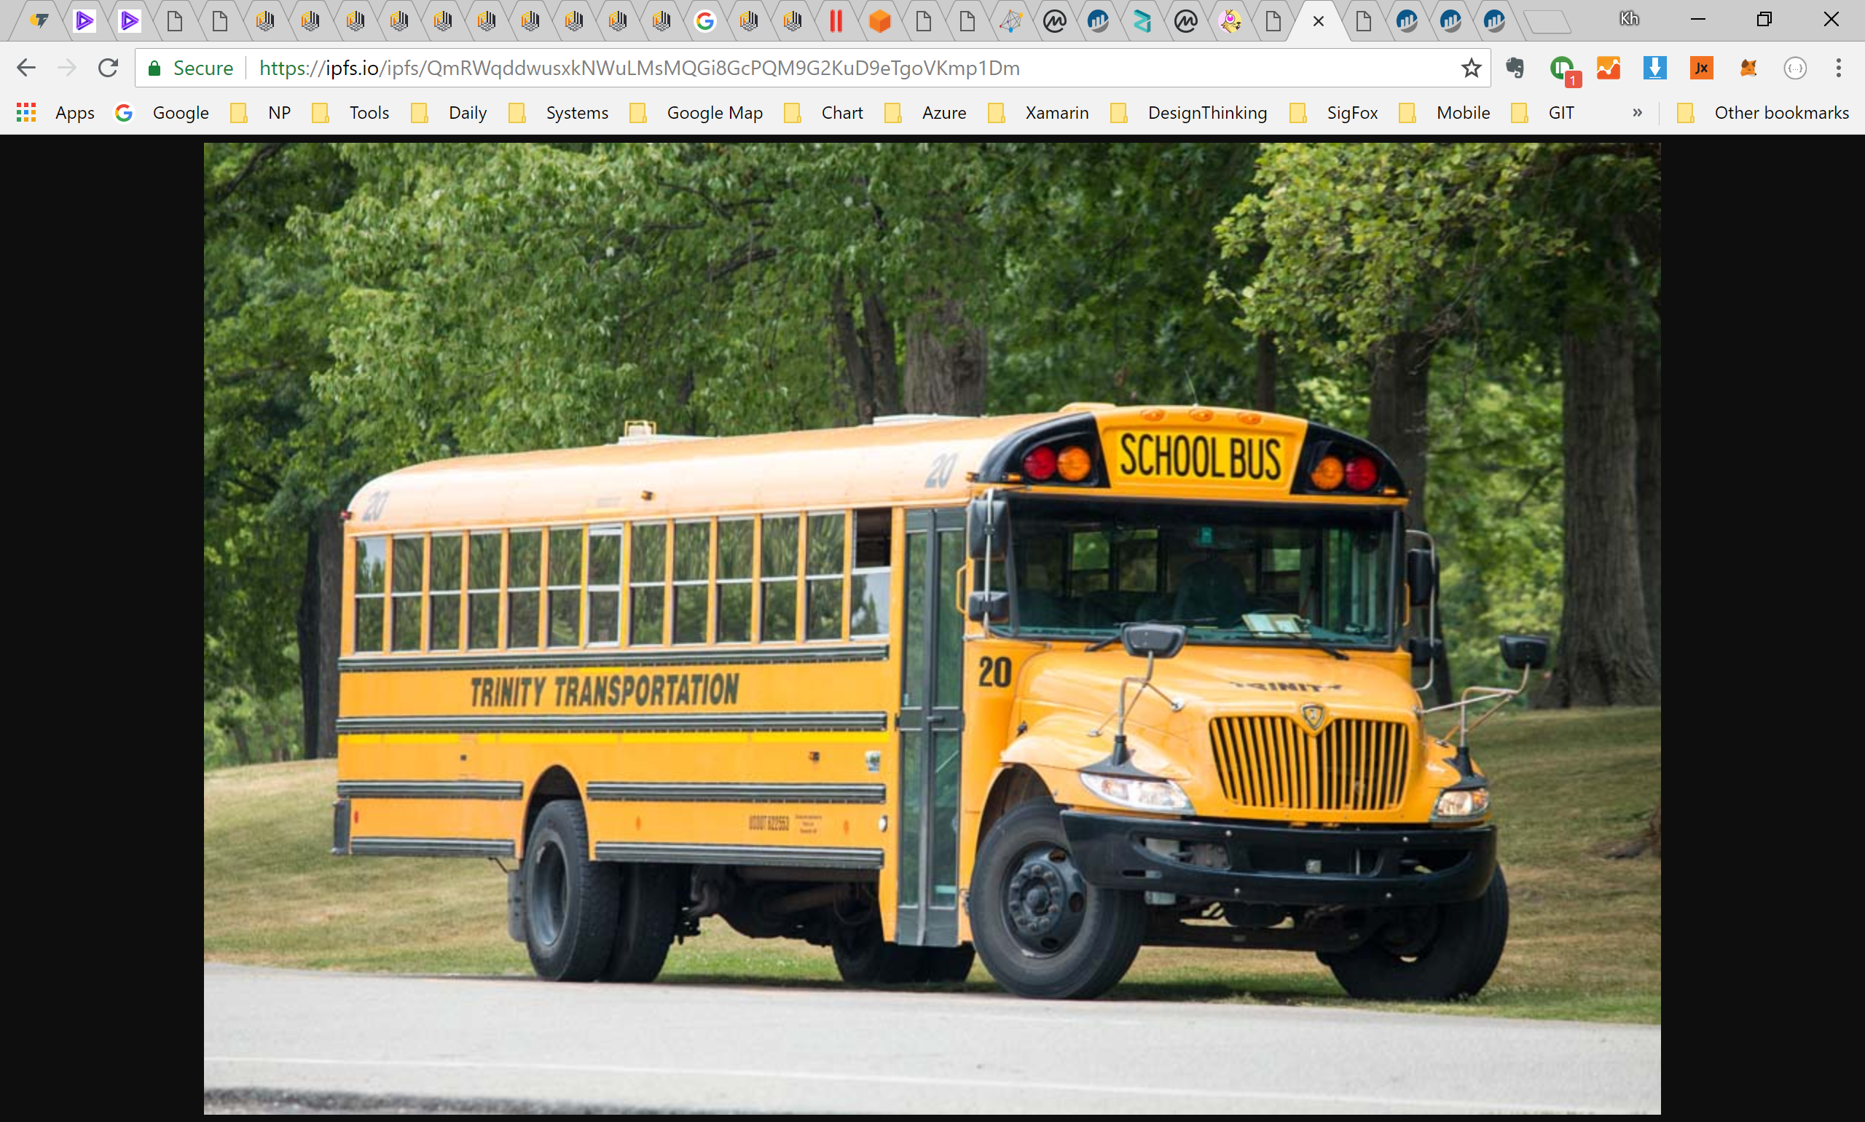

View txn details on ropsten.etherscan.io 0x85ded is txn hash

